Rectangular-Base Prism
# Source: AI Source: Provided by: [Data Path: Persons Table -> ID Column: 1, Name_En Column: Motasem Essam] -> From: [ChatGPT] on [7/25/2026]
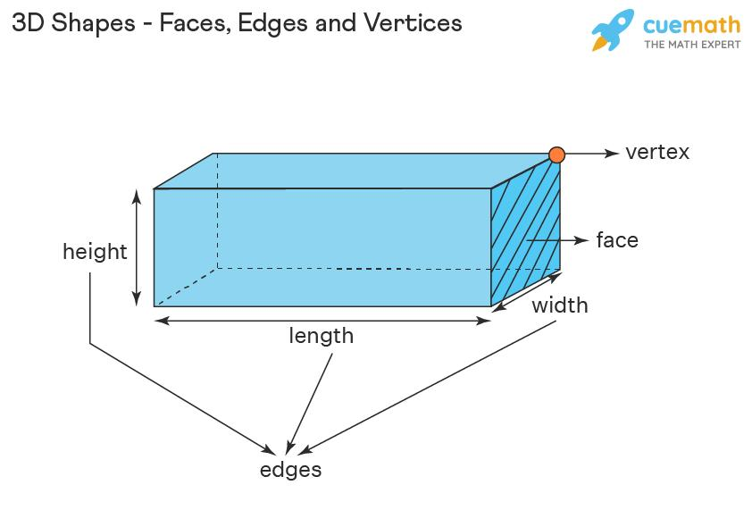
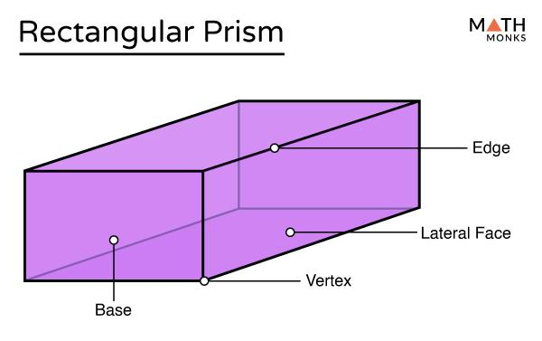
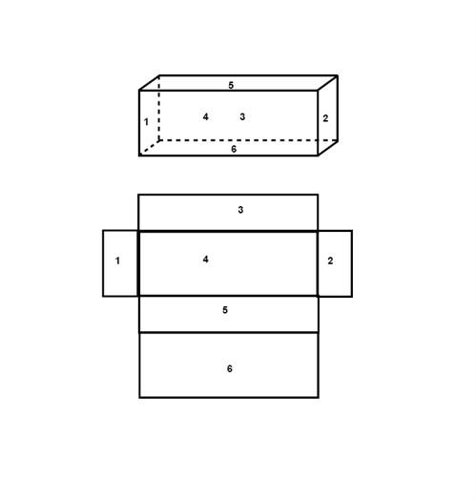

Definition
# Source: AI Source: Provided by: [Data Path: Persons Table -> ID Column: 1, Name_En Column: Motasem Essam] -> From: [ChatGPT] on [7/25/2026]
A rectangular-base prism is a three-dimensional prism whose two congruent, parallel bases are rectangles. The bases are connected by four lateral faces, forming a closed polyhedron.
A rectangular-base prism can be a right prism or an oblique prism. In a right rectangular-base prism, the lateral edges are perpendicular to the bases, and all lateral faces are rectangles. In an oblique rectangular-base prism, the lateral edges are inclined, and the lateral faces are parallelograms.
A rectangular prism in the common school-geometry sense usually refers to a right rectangular prism, also called a cuboid. A cube is a special rectangular prism in which all six faces are squares.

Simple Definition
# Source: AI Source: Provided by: [Data Path: Persons Table -> ID Column: 1, Name_En Column: Motasem Essam] -> From: [ChatGPT] on [7/25/2026]
A rectangular-base prism is a solid with two identical, parallel rectangular bases connected by four side faces.
Its two bases are rectangles, and its four lateral faces are generally parallelograms or, in a right prism, rectangles.

Classification Tree
# Source: AI Source: Provided by: [Data Path: Persons Table -> ID Column: 1, Name_En Column: Motasem Essam] -> From: [ChatGPT] on [7/25/2026]
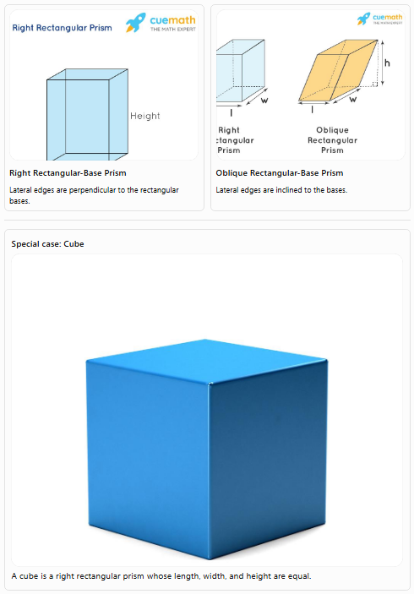
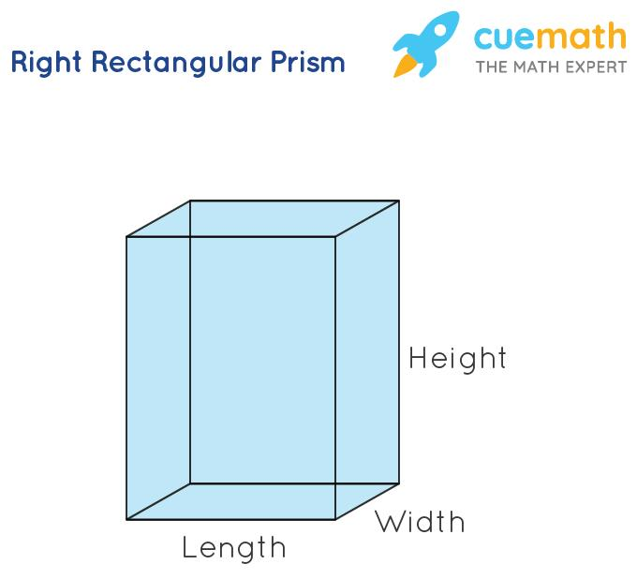
Right Rectangular-Base Prism
Lateral edges are perpendicular to the rectangular bases.
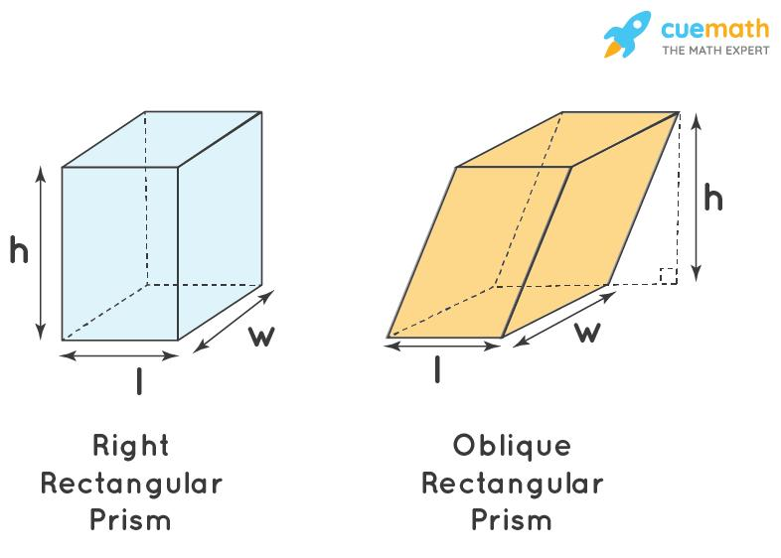
Oblique Rectangular-Base Prism
Lateral edges are inclined to the bases.
Special case: Cube
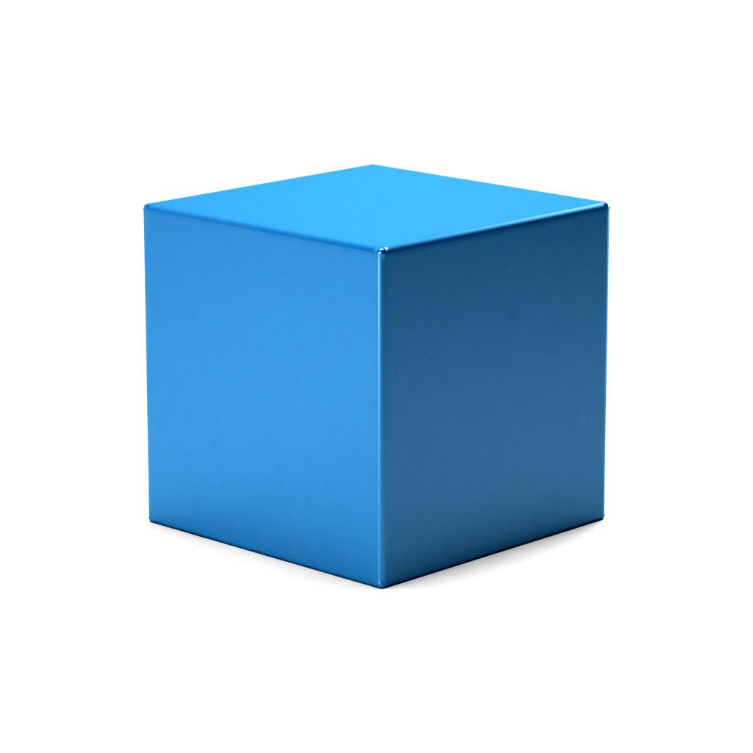
A cube is a right rectangular prism whose length, width, and height are equal.

Key Characteristics
# Source: AI Source: Provided by: [Data Path: Persons Table -> ID Column: 1, Name_En Column: Motasem Essam] -> From: [ChatGPT] on [7/25/2026]
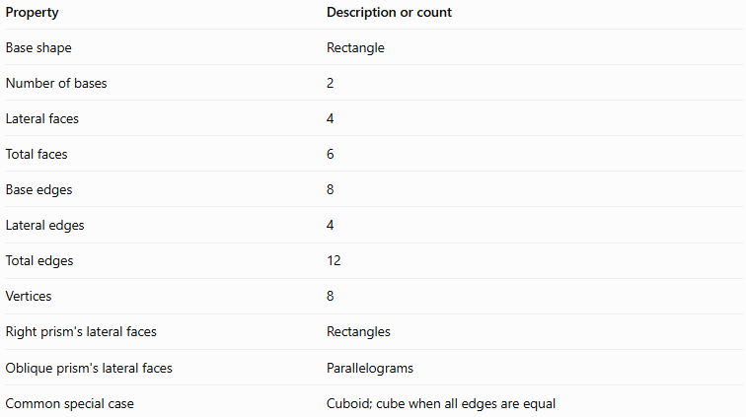
Property | Description or count
Base shape | Rectangle
Number of bases | 2
Lateral faces | 4
Total faces | 6
Base edges | 8
Lateral edges | 4
Total edges | 12
Vertices | 8
Right prism's lateral faces | Rectangles
Oblique prism's lateral faces | Parallelograms
Common special case | Cuboid; cube when all edges are equal

Geometric Representation
# Source: AI Source: Provided by: [Data Path: Persons Table -> ID Column: 1, Name_En Column: Motasem Essam] -> From: [ChatGPT] on [7/25/2026]
The principal components of a rectangular-base prism are:
- Rectangular bases: Two congruent, parallel rectangles.
- Lateral faces: Four faces joining the corresponding edges of the bases.
- Base edges: Eight edges in total, with four around each base.
- Lateral edges: Four edges connecting corresponding vertices of the bases.
- Vertices: Eight corner points.
- Height: The perpendicular distance between the two base planes.
- Length and width: The dimensions of a rectangular base.
For a right rectangular prism, let the base dimensions be $l$ and $w$, and let the perpendicular height be $h$.

Mathematical Representations and Formulas
# Source: AI Source: Provided by: [Data Path: Persons Table -> ID Column: 1, Name_En Column: Motasem Essam] -> From: [ChatGPT] on [7/25/2026]
Let:
- $l$ = length of the rectangular base
- $w$ = width of the rectangular base
- $h$ = perpendicular height of the prism
- $B$ = area of one base
- $A_{L}$ = lateral surface area
- $A_{T}$ = total surface area
- $V$ = volume

A. Number of faces, edges, and vertices
# Source: AI Source: Provided by: [Data Path: Persons Table -> ID Column: 1, Name_En Column: Motasem Essam] -> From: [ChatGPT] on [7/25/2026]
A rectangular-base prism is a quadrilateral prism, so $n=4$.
For an $n$-gonal prism:
$$F=n+2, E=3n, V=2n$$
Substituting $n=4$:
$$F=4+2=\boxed{6}$$
$$E=3\left(4\right)=\boxed{12}$$
$$V=2\left(4\right)=\boxed{8}$$

B. Area of the rectangular base
# Source: AI Source: Provided by: [Data Path: Persons Table -> ID Column: 1, Name_En Column: Motasem Essam] -> From: [ChatGPT] on [7/25/2026]
The area of a rectangle is length multiplied by width:
$$\boxed{B=lw}$$

C. Volume
# Source: AI Source: Provided by: [Data Path: Persons Table -> ID Column: 1, Name_En Column: Motasem Essam] -> From: [ChatGPT] on [7/25/2026]
The volume of a prism is its base area multiplied by its perpendicular height:
$$V=Bh$$
Since $B=lw$:
$$\boxed{V=lwh}$$
This formula applies to both right and oblique prisms when $h$ is the perpendicular distance between the bases.

D. Lateral surface area
# Source: AI Source: Provided by: [Data Path: Persons Table -> ID Column: 1, Name_En Column: Motasem Essam] -> From: [ChatGPT] on [7/25/2026]
For a right prism, the lateral surface area is the base perimeter multiplied by the height:
$$A_{L}=ph$$
The rectangular base perimeter is:
$$p=2\left(l+w\right)$$
Therefore:
$$\boxed{A_{L}=2h\left(l+w\right)}$$
This formula applies to right rectangular-base prisms. For an oblique prism, calculate the actual areas of the four lateral parallelograms and add them.

E. Total surface area
# Source: AI Source: Provided by: [Data Path: Persons Table -> ID Column: 1, Name_En Column: Motasem Essam] -> From: [ChatGPT] on [7/25/2026]
The total surface area is the sum of all six faces:
$$A_{T}=A_{L}+2B$$
Substituting the formulas for a right rectangular prism:
$$A_{T}=2h\left(l+w\right)+2lw$$
Thus:
$$\boxed{A_{T}=2\left(lw+lh+wh\right)}$$

F. Space diagonal of a rectangular prism
# Source: AI Source: Provided by: [Data Path: Persons Table -> ID Column: 1, Name_En Column: Motasem Essam] -> From: [ChatGPT] on [7/25/2026]
The space diagonal joins two opposite vertices through the interior of the solid.
Using the three dimensions:
$$\boxed{d=\sqrt{l^{2}+w^{2}+h^{2}}}$$
This formula applies to a right rectangular prism.

G. Special case: Cube
# Source: AI Source: Provided by: [Data Path: Persons Table -> ID Column: 1, Name_En Column: Motasem Essam] -> From: [ChatGPT] on [7/25/2026]
For a cube, all three dimensions equal $a$:
$$l=w=h=a$$
Its volume is:
$$\boxed{V=a^{3}}$$
Its total surface area is:
$$\boxed{A_{T}=6a^{2}}$$
Its space diagonal is:
$$\boxed{d=a\sqrt{3}}$$

Worked Examples
# Source: AI Source: Provided by: [Data Path: Persons Table -> ID Column: 1, Name_En Column: Motasem Essam] -> From: [ChatGPT] on [7/25/2026]
Example 1: Counting faces, edges, and vertices
Problem: Determine the number of faces, edges, and vertices of a rectangular-base prism.
Solution:
The base is a quadrilateral, so $n=4$.
$$F=n+2=4+2=\boxed{6}$$
$$E=3n=3\left(4\right)=\boxed{12}$$
$$V=2n=2\left(4\right)=\boxed{8}$$
Answer: The prism has 6 faces, 12 edges, and 8 vertices.
Example 2: Calculating volume
Problem: A right rectangular prism has a length of $8\text{ cm}$, a width of $5\text{ cm}$, and a height of $3\text{ cm}$. Find its volume.
Step 1: Calculate the base area.
$$B=lw=8\left(5\right)=40{\text{ cm}}^{2}$$
Step 2: Calculate the volume.
$$V=Bh=40\left(3\right)$$
$$\boxed{V=120{\text{ cm}}^{3}}$$
Answer: $120{\text{ cm}}^{3}$.
Example 3: Calculating total surface area
Problem: A right rectangular prism has dimensions $l=8\text{ cm}$, $w=5\text{ cm}$, and $h=3\text{ cm}$. Find its total surface area.
Use the formula:
$$A_{T}=2\left(lw+lh+wh\right)$$
Substitute the values:
$$A_{T}=2\left[\left(8\right)\left(5\right)+\left(8\right)\left(3\right)+\left(5\right)\left(3\right)\right]$$
$$A_{T}=2\left(40+24+15\right)$$
$$A_{T}=2\left(79\right)$$
$$\boxed{A_{T}=158{\text{ cm}}^{2}}$$
Answer: $158{\text{ cm}}^{2}$.
Example 4: Calculating the space diagonal
Problem: A rectangular prism has length $6\text{ cm}$, width $4\text{ cm}$, and height $3\text{ cm}$. Find its space diagonal.
Use:
$$d=\sqrt{l^{2}+w^{2}+h^{2}}$$
Substitute:
$$d=\sqrt{6^{2}+4^{2}+3^{2}}$$
$$d=\sqrt{36+16+9}$$
$$\boxed{d=\sqrt{61}≈7.81\text{ cm}}$$
Answer: Approximately $7.81\text{ cm}$.
Example 5: Verifying Euler's formula
Euler's formula for a convex polyhedron is:
$$V-E+F=2$$
For a rectangular-base prism:
$$8-12+6=2$$
$$\boxed{2=2}$$
Therefore, the rectangular-base prism satisfies Euler's formula.

Comparison with Related Quadrilateral Prisms
# Source: AI Source: Provided by: [Data Path: Persons Table -> ID Column: 1, Name_En Column: Motasem Essam] -> From: [ChatGPT] on [7/25/2026]
The shape of a quadrilateral base determines the type of quadrilateral prism. The number of faces, edges, and vertices remains the same for ordinary quadrilateral prisms.
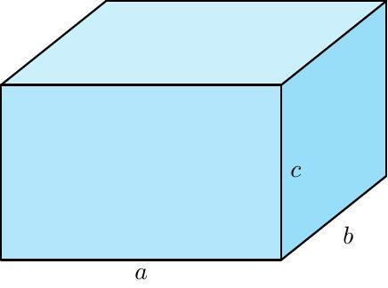
Rectangular-Base Prism
Bases are rectangles. A right version is a cuboid, with all six faces rectangular.
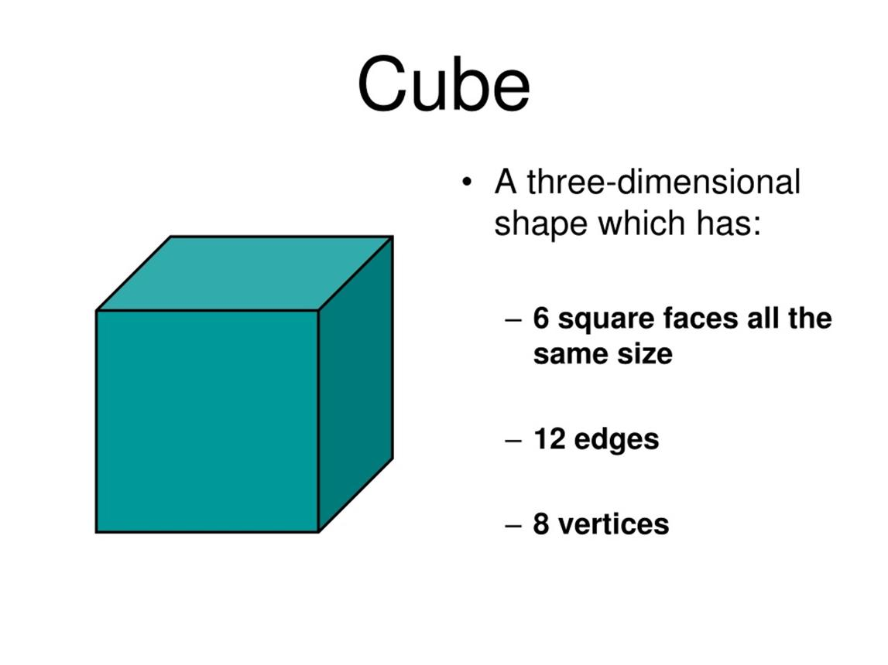
Square Prism
Bases are squares. A right square prism has square bases and rectangular lateral faces; a cube is its special case with all edges equal.
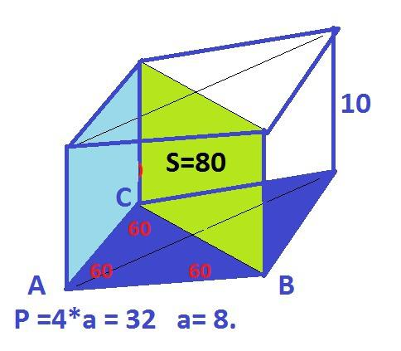
Rhombus-Base Prism
Bases are rhombuses. In a right prism, the lateral faces are rectangles, but the bases need not have right angles.
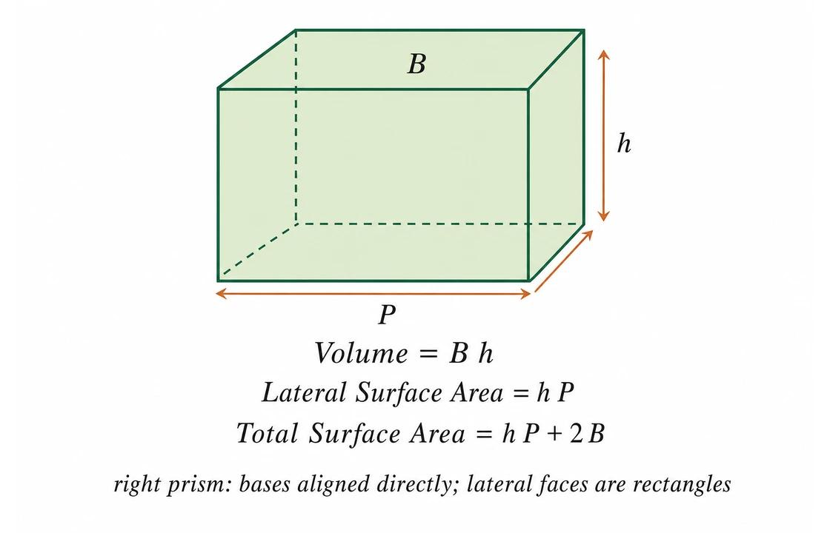
Parallelogram-Base Prism
Bases are parallelograms. The base angles need not be right angles.
Important distinction: A rectangular-base prism is defined by its rectangular bases. A cuboid is a right rectangular prism, and a cube is a special cuboid with all edges equal.

Constructing Rectangular-Base Prism (Cuboid)

Instruments Used
# Source: AI Source: Provided by: [Data Path: Persons Table -> ID Column: 1, Name_En Column: Motasem Essam] -> From: [ChatGPT] on [7/25/2026]
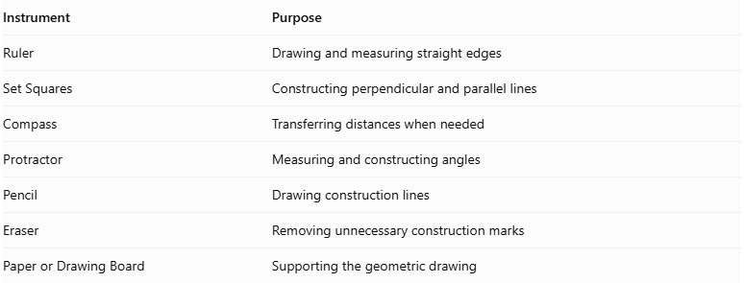
Instrument | Purpose
Ruler | Drawing and measuring straight edges
Set Squares | Constructing perpendicular and parallel lines
Compass | Transferring distances when needed
Protractor | Measuring and constructing angles
Pencil | Drawing construction lines
Eraser | Removing unnecessary construction marks
Paper or Drawing Board | Supporting the geometric drawing

Construction Procedures

Isometric Construction
# Source: AI Source: Provided by: [Data Path: Persons Table -> ID Column: 1, Name_En Column: Motasem Essam] -> From: [ChatGPT] on [7/25/2026]
- Determine the required length, width, and height.
- Draw the front vertical edge of the cuboid.
- From its upper and lower endpoints, draw two receding edges at the appropriate isometric angle.
- Mark the required width and length along the receding directions.
- Draw vertical edges from the corresponding endpoints to represent the height.
- Connect the corresponding vertices to complete the top, side, and front faces.
- Identify visible and hidden edges.
- Refine the drawing and label the dimensions.
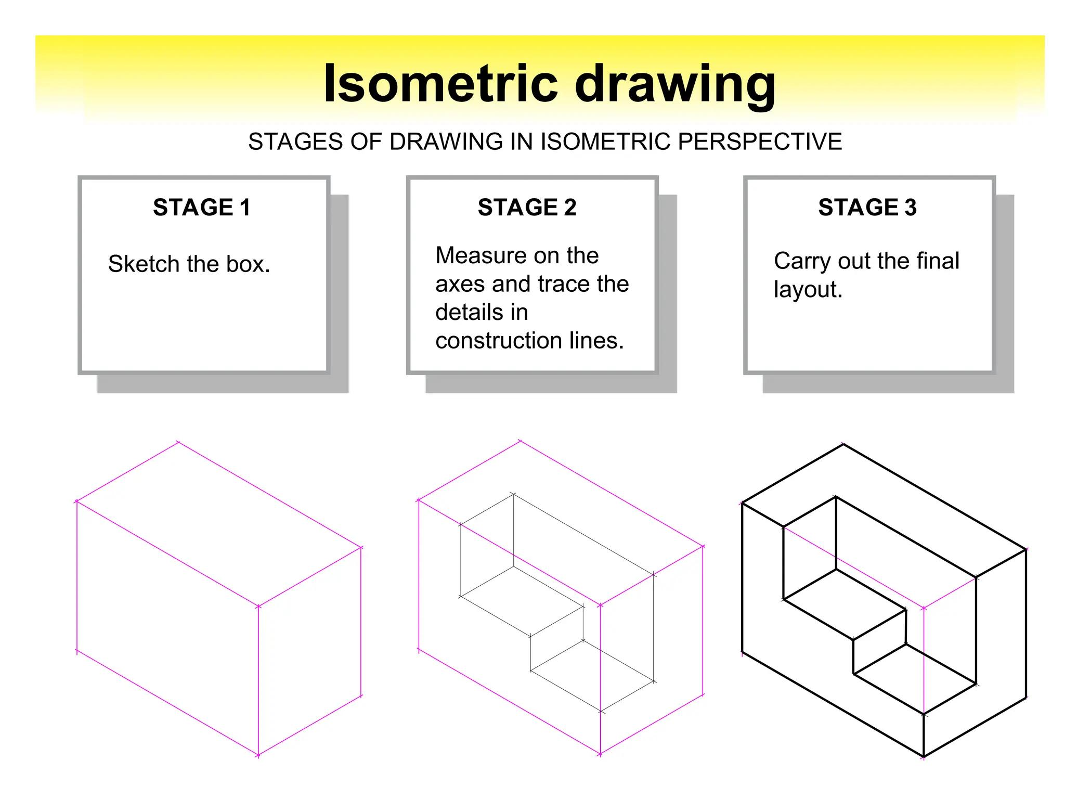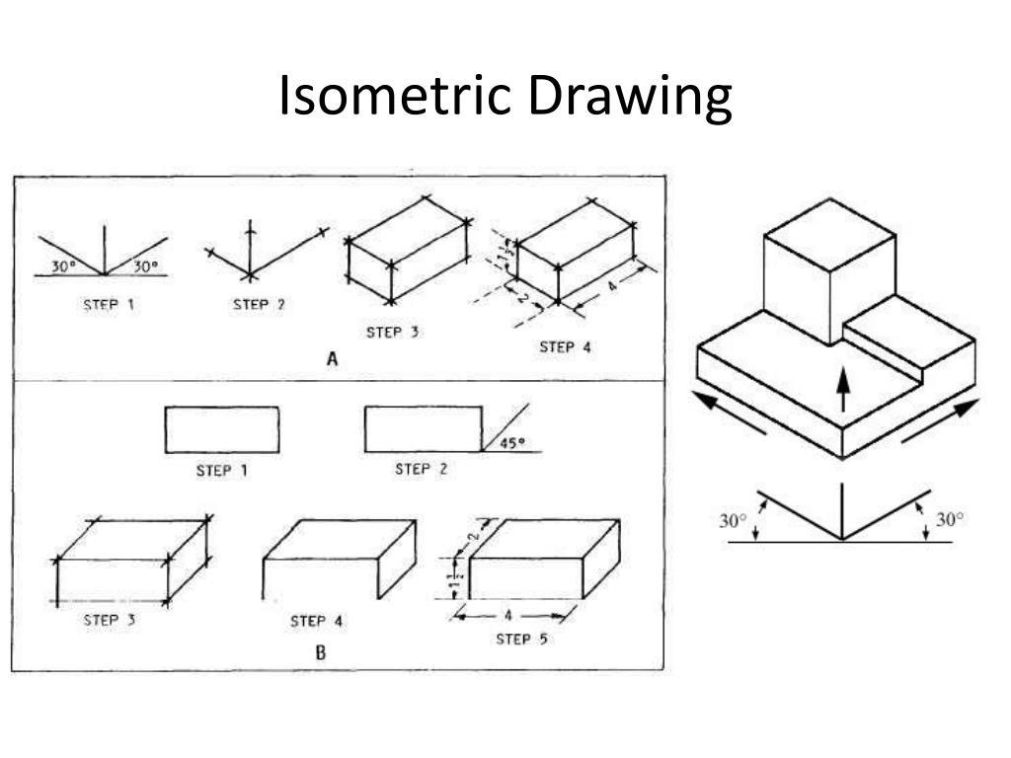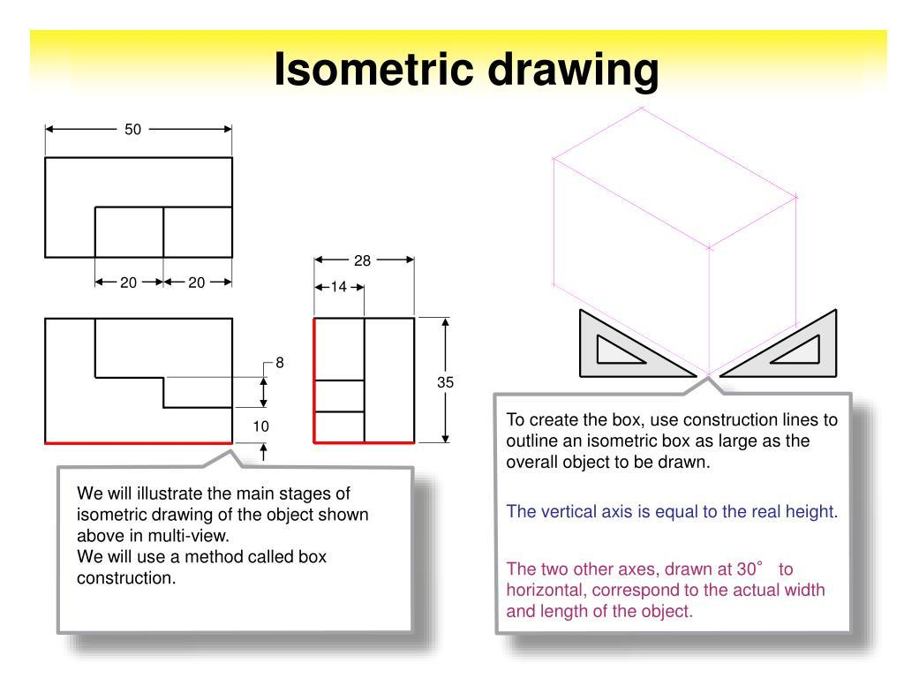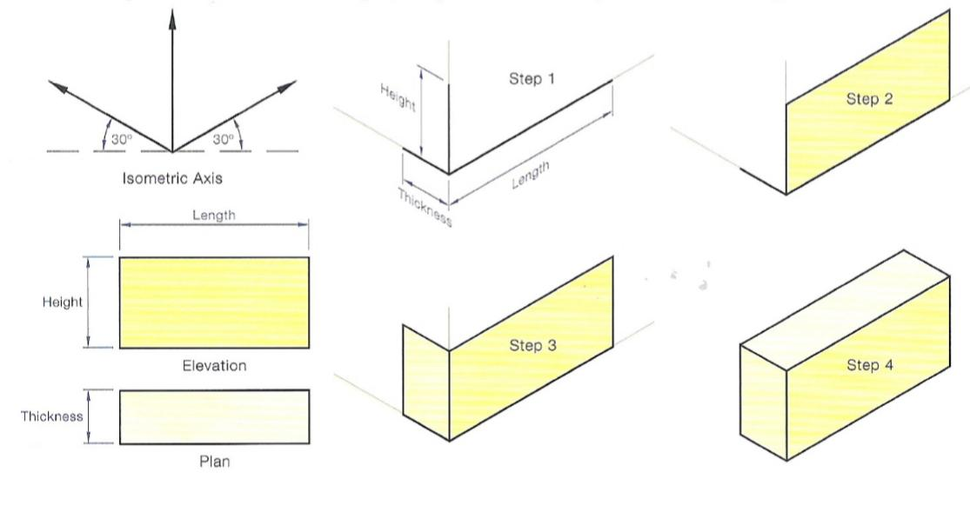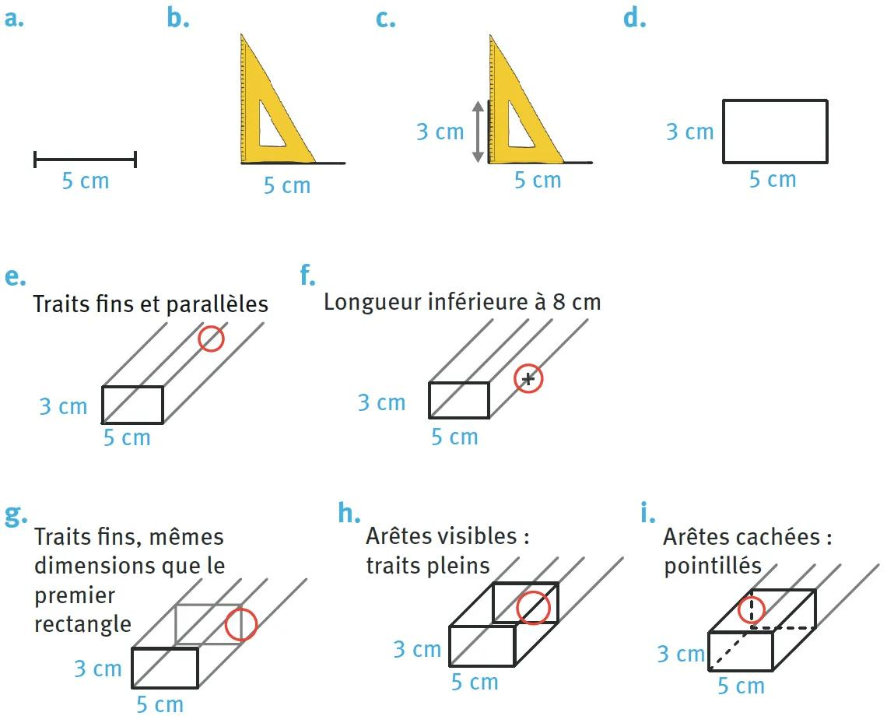

Orthographic Construction
# Source: AI Source: Provided by: [Data Path: Persons Table -> ID Column: 1, Name_En Column: Motasem Essam] -> From: [ChatGPT] on [7/25/2026]
- Determine the length, width, and height.
- Draw the front rectangular view using the length and height.
- Draw the top rectangular view using the length and width.
- Draw the side rectangular view using the width and height.
- Align the three views according to the selected orthographic projection convention.
- Ensure that corresponding edges have matching dimensions.
- Add visible and hidden lines where necessary.
- Label the three principal dimensions.

Face-Based Construction
# Source: AI Source: Provided by: [Data Path: Persons Table -> ID Column: 1, Name_En Column: Motasem Essam] -> From: [ChatGPT] on [7/25/2026]
- Draw the rectangular front face.
- Determine the required depth of the cuboid.
- Draw the corresponding rear rectangular face using the same dimensions.
- Connect the corresponding vertices of both rectangles.
- Ensure that the connecting edges are parallel and equal in length.
- Complete the six faces.
- Distinguish visible edges from hidden edges.

Edge-Based Construction
# Source: AI Source: Provided by: [Data Path: Persons Table -> ID Column: 1, Name_En Column: Motasem Essam] -> From: [ChatGPT] on [7/25/2026]
- Select a starting vertex.
- Draw three edges representing length, width, and height.
- Ensure that the three principal edges meet at right angles in the actual solid.
- Complete the remaining parallel edges.
- Ensure that opposite edges have equal lengths.
- Connect all corresponding endpoints.
- Check that the resulting solid has six rectangular faces.

Net-Based Construction
# Source: AI Source: Provided by: [Data Path: Persons Table -> ID Column: 1, Name_En Column: Motasem Essam] -> From: [ChatGPT] on [7/25/2026]
- Draw six rectangles representing the six faces of the cuboid.
- Arrange four rectangles in a connected strip to form the lateral faces.
- Attach the remaining two rectangles as the top and bottom faces.
- Ensure that adjoining edges have matching lengths.
- Add tabs if needed for physical assembly.
- Cut out the net.
- Fold along the edges and join the matching boundaries to form the cuboid.
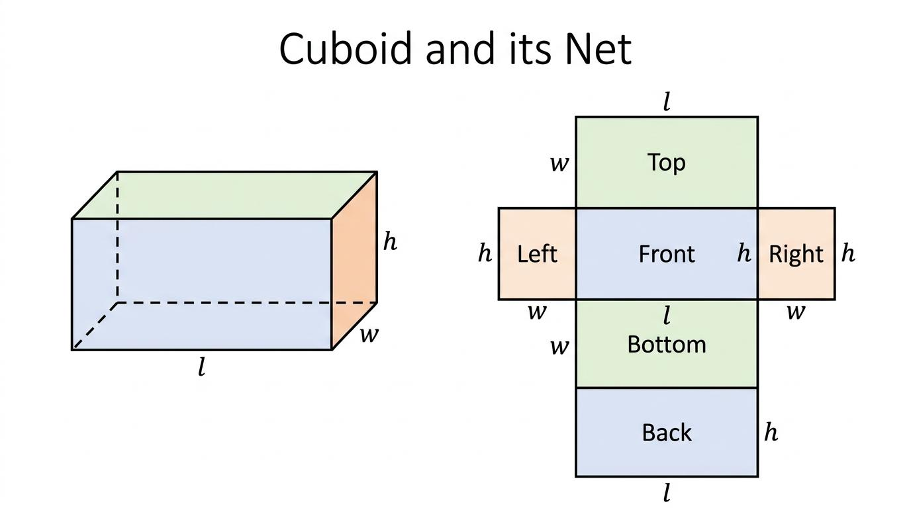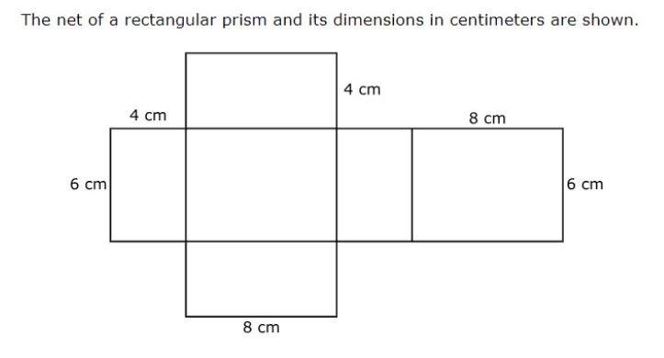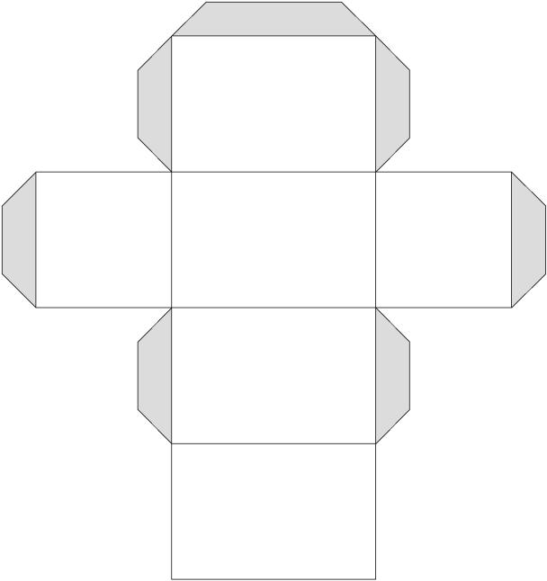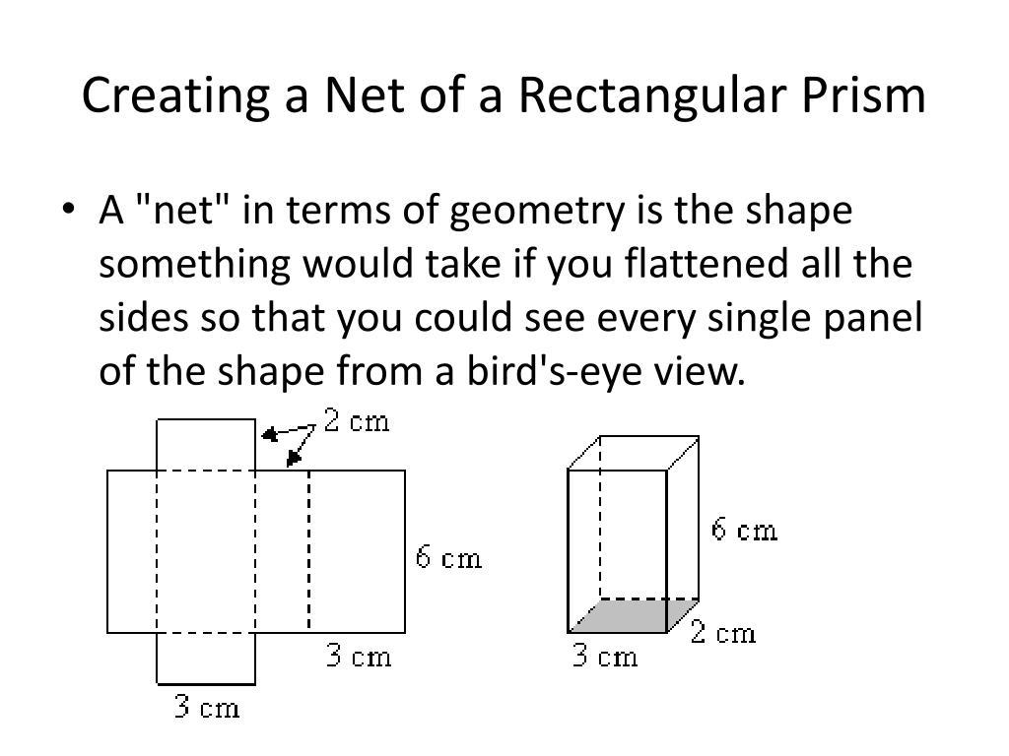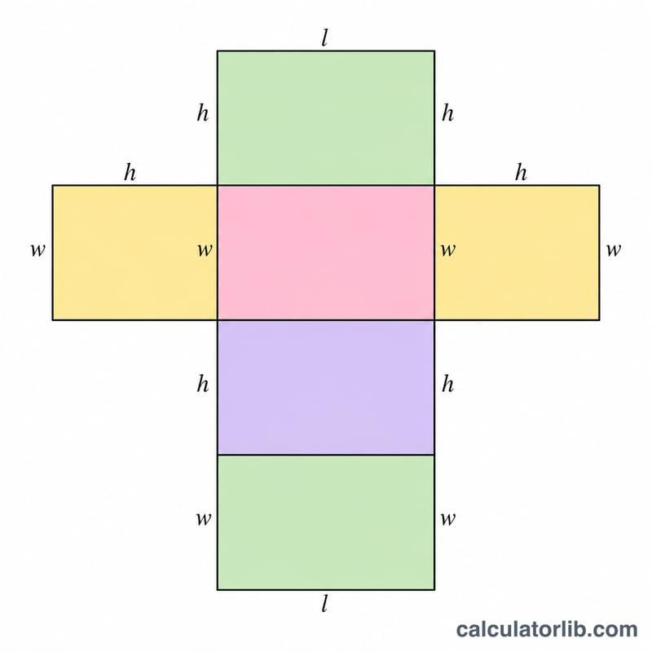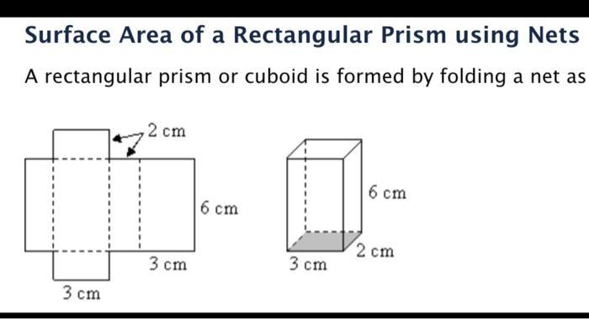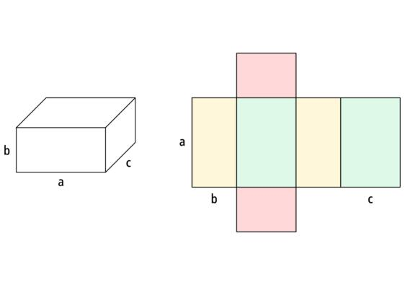

Applications of Rectangular-Base Prisms
# Source: AI Source: Provided by: [Data Path: Persons Table -> ID Column: 1, Name_En Column: Motasem Essam] -> From: [ChatGPT] on [7/25/2026]
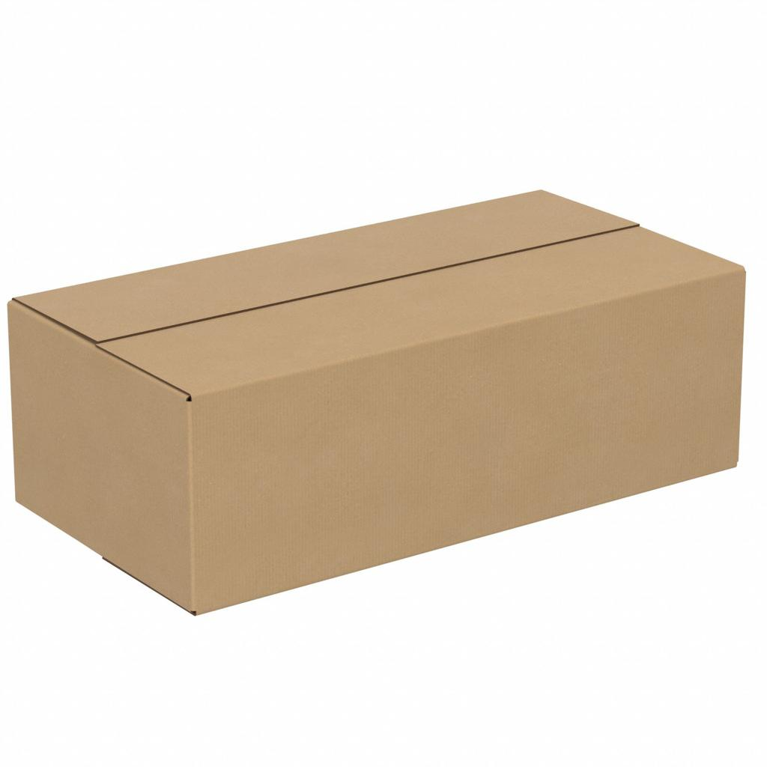
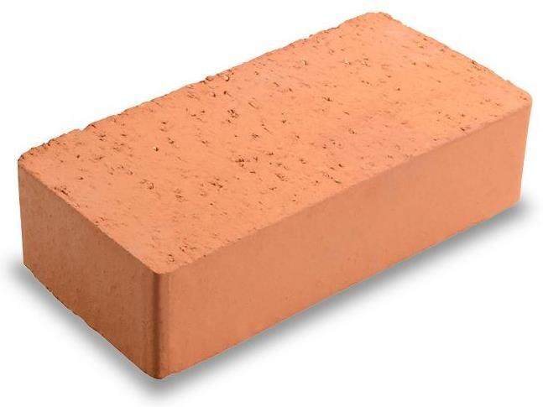
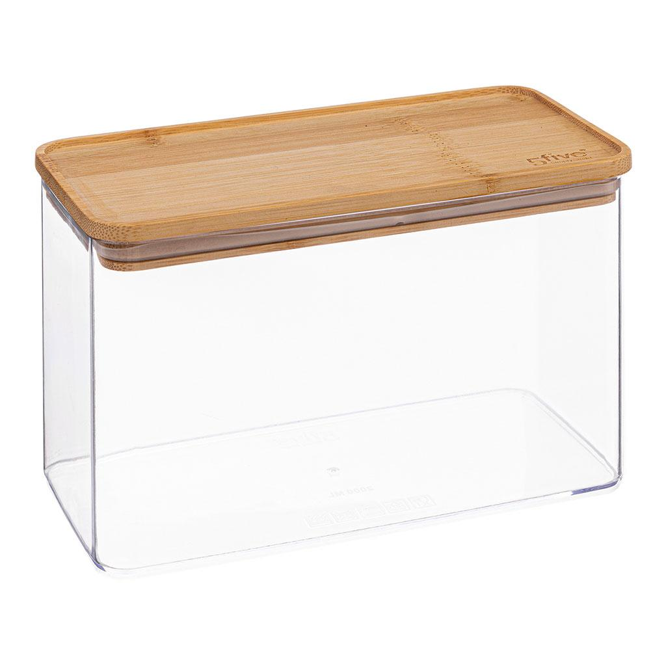
Rectangular-base prisms are common in everyday life and technical fields:
- Packaging: Boxes, cartons, and storage containers.
- Construction: Bricks, blocks, and rectangular structural components.
- Furniture: Cabinets, drawers, shelves, and tabletops.
- Engineering: Modeling rectangular components and calculating material requirements.
- Mathematics: Teaching volume, surface area, diagonals, and three-dimensional coordinates.

Key Points
# Source: AI Source: Provided by: [Data Path: Persons Table -> ID Column: 1, Name_En Column: Motasem Essam] -> From: [ChatGPT] on [7/25/2026]
- A rectangular-base prism has two congruent, parallel rectangular bases.
- It has four lateral faces, six faces in total, twelve edges, and eight vertices.
- Its base area is $B=lw$.
- Its volume is $V=lwh$.
- For a right rectangular prism, its lateral surface area is $A_{L}=2h\left(l+w\right)$.
- Its total surface area is $A_{T}=2\left(lw+lh+wh\right)$.
- Its space diagonal is $d=\sqrt{l^{2}+w^{2}+h^{2}}$.
- A cube is a special rectangular prism whose length, width, and height are equal.

Conclusion
# Source: AI Source: Provided by: [Data Path: Persons Table -> ID Column: 1, Name_En Column: Motasem Essam] -> From: [ChatGPT] on [7/25/2026]
A rectangular-base prism is a quadrilateral prism whose two congruent, parallel bases are rectangles. It has six faces, twelve edges, and eight vertices. When its lateral edges are perpendicular to the bases, it is a right rectangular prism, commonly called a cuboid.
Its volume is calculated by multiplying the base length, base width, and perpendicular height. Its total surface area is the sum of the areas of its six rectangular faces, and its space diagonal can be found using the three-dimensional Pythagorean theorem.
Understanding rectangular-base prisms provides a foundation for studying other quadrilateral prisms, including square-base, rhombus-base, and parallelogram-base prisms.

